**Module 3 Testing on Live Application**

* **What is RDBMS?**

RDBMS stands for Relational Database Management System. RDBMS is the basis for SQL, and for all modern database systems like MS SQL Server, IBM DB2, Oracle, MySQL, and Microsoft Access.

* **What is SQL?**

SQL is Structured Query Language, which is a computer language for storing, manipulating and retrieving data stored in relational database.

* **Write SQL Commands?**
* **DDL** – Data Definition Language.
* **DML** – Data Manipulation Language.
* **DCL** – Data Control Language.
* **DQL** – Data Query Language.
* **What is join?**

JOIN is used to same data base retrieving & interlink the records from multiple tables**.**

* **Write type of joins?**
* **INNER JOIN**: returns rows when there is a match in both tables.
* **LEFT JOIN**: returns all rows from the left table, even if there are no matches in the right table.
* **RIGHT JOIN**: returns all rows from the right table, even if there are no matches in the left table.
* **FULL JOIN**: returns rows when there is a match in one of the tables.
* **How Many constraint and describes itself?**
* **NOT NULL:** This constraint tells that we cannot store a null value in a column. That is, if a column is specified as NOT NULL then we will not be able to store null in this particular column any more.
* **UNIQUE:** This constraint when specified with a column, tells that all the values in the column must be unique. That is, the values in any row of a column must not be repeated.
* **PRIMARY KEY:** A primary key is a field which can uniquely identify each row in a table. And this constraint is used to specify a field in a table as primary key.
* **FOREIGN KEY:** A Foreign key is a field which can uniquely identify each row in a table. And this constraint is used to specify a field as foreign key.
* **CHECK:** This constraint helps to validate the values of a column to meet a particular condition. That is, it helps to ensure that the value stored in a column meets a specific condition.
* **DEFAULT:** This constraint specifies a default value for the column when no value is specified by the user.
* **Difference between RDBMS vs DBMS**

|  |  |
| --- | --- |
| **RDBMS** | **DBMS** |
| RDBMS stores data in tabular form | DBMS stores data as file. |
| Multiple data elements can be accessed at the same time | Data elements need to access individually |
| Data is stored in the form of tables which are related to each other | No relationship between data |
| It is used to handle large amount of data | It is used for small organization and deal with small data |
| More security measures provided. | Security is less |
| Data fetching is fast because of relational approach | Data fetching is slower for the large amount of data |

* **What is API Testing?**

API (Application Programming Interface) is a computing interface which enables communication and data exchange between two separate software systems.

* **Types of API Testing?**
* **Open APIs**: These types of APIs are publicly available to use like OAuth APIs from Google. It has also not given any restriction to use them. So, they are also known as Public APIs.
* **Partner APIs**: Specific rights or licenses to access this type of API because they are not available to the public.
* **Internal APIs**: Internal or private. These APIs are developed by companies to use in their internal systems. It helps you to enhance the productivity of your teams.
* **What is Responsive Testing?**

Responsive testing is a process that enables you to check how well a website or application screen size, resolutions works on various types of devices like laptops, desktops and smartphones.

* **Which types of tools are available for Responsive Testing?**
* **LT Browser**
* **Lembda Testing**
* **Google Resizer**
* **I am responsive**
* **Pixel tuner**
* **What is the full form of .ipa, .apk?**
* An IPA (iOS App Store Package) file is an iOS application archive file that stores an iOS app. Each IPA file includes a binary and can only be installed on an iOS device.
* APK file stands for (Android Application Package). APK is a file extension of an Android device. APK files can normally be used in Android and a number of other Android-based Operating Systems.
* **How to create step for to open the developer option mode ON?**

1 2 3

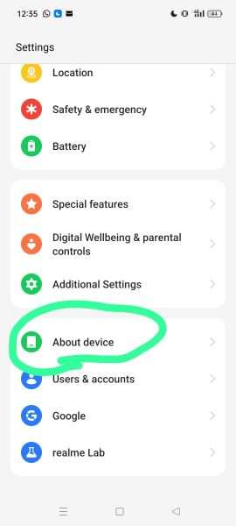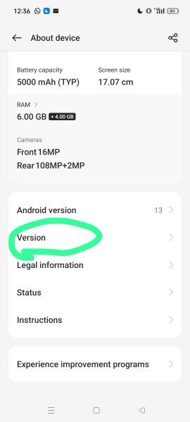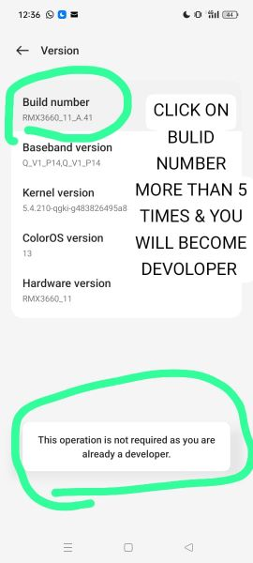

4 5 6

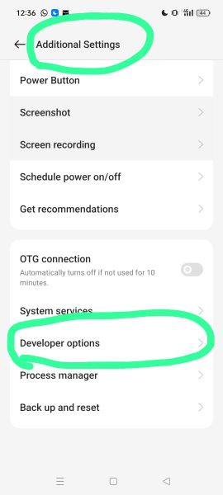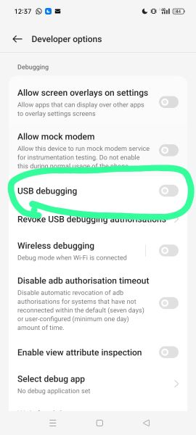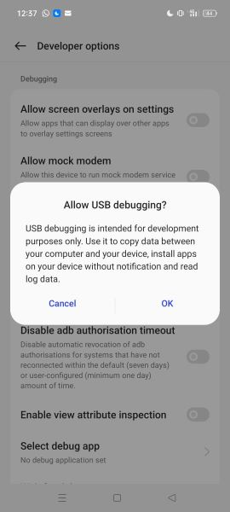

* What is Automation Core Testing, Load Runner Up and Selenium IDE?
* **Automation Core Testing**: Automation Testing is the method of testing software products with special testing tools and frameworks to minimize human intervention and maximize quality**.**
* **Load Runner:** Load Runner is a software tool that simulates the real world user’s actions and helps to identify the performance of the software application or system by generating virtual load by Doing **Stress Testing, Load Testing and Performance Testing**.
* **Selenium IDE:** Selenium is a free (open source) automated testing suite for only for web applications. It is a suite of software for each catering by its four components like **Selenium Integrated Development Environment (IDE), Selenium Remote Control (RC), Selenium Web Driver and Selenium Grid.**

But now Selenium Web Driver & Selenium Grid are merged in to Selenium 2.

* **Which components have you used in Load Runner?**
* **Stress Testing:** Stress Testing is done in order to check when the application fails by reducing the system resources such as RAM, HDD etc. and keeping the number of users as constant.
* **Load Testing**: Load Testing is done in order to check when the application fails by increasing the number of users and keeping the system resources as constant.
* **Performance Testing:** The term performance can mean measuring response tie, throughput resource utilization, or some other system characteristic (or group them) by varying the number of users.
* **How can you set the number of Vusers in Load Runner?**
* Segaue Silk Performer
* Rational Team Test
* Mercury Load Runner
* HP Load Runner Up
* Empirix e-Load/RSW
* Soft Light Tools Loader
* **What is Correlation?**